April 2015 Duck Tales
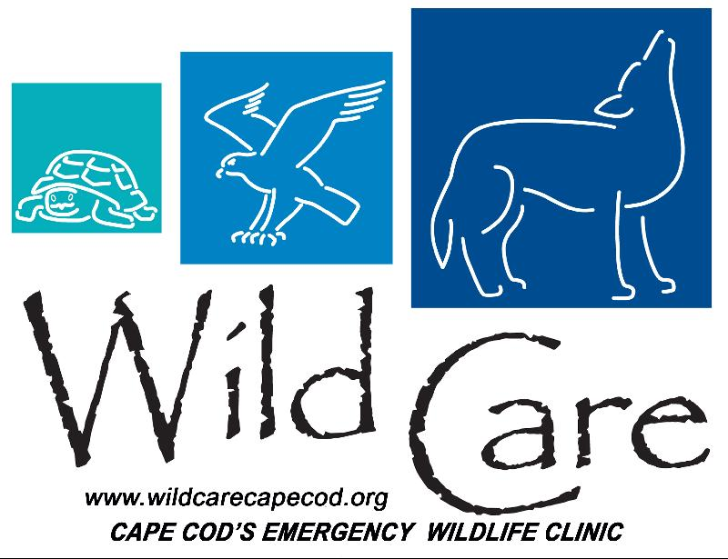

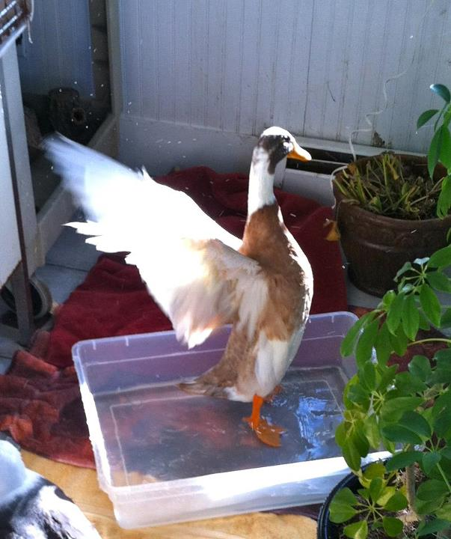
"DUCK TALES"

Wild Care's Monthly E-News

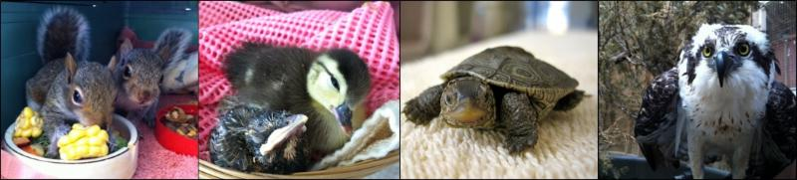

To learn more about Wild Care, visit our web site!
www.wildcarecapecod.org

  He's Number One!!
  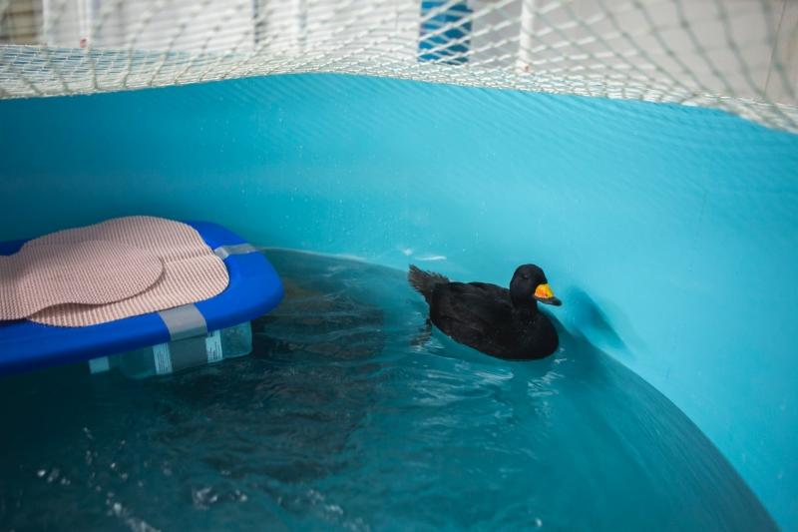
  Photo: Julia Cumes
  This Black Scoter was our very first Sea Bird Therapy Pool swimmer! Found in Harwich, he did amazingly well in the pool ~ getting great exercise in the current and proving that these pools are a fantastic investment in Wild Care's mission to rehabilitate injured seabirds and waterfowl of Cape Cod. His recovery was swift and we successfully released him, ready to swim again in the wild.
  Slow But Steady Recovery
  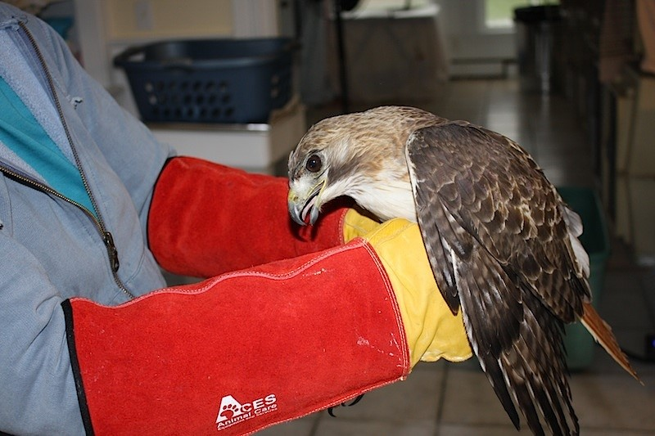
  Photo: Julie O'Neil
  On April 13th, this Red Tailed Hawk was brought into Wild Care from Brewster by home owners who heard the bird strike their house. He was suffering from a bad concussion and torticollis, a twisted neck condition, but he had no wing fractures. He is still in our clinic and we are encouraged by his continuing recovery. He recently was able to take several pieces of mouse on his own to feed, and other signs of gradual improvement are very promising.
  Want to help? Please consider making a donation today. Click here to go to our Donation page.
  Wild Care's 21st Annual Yard Sale
  Mark your calendars for the 21st annual WILD CARE YARD SALE on June 13th.
  Doing your spring cleaning? Save those valuable resale items for this annual Yard Sale fundraiser at the Harwich Community Center. Drop off items on Friday June 12th from 12 noon to 6pm, and the sale itself is Saturday June 13th from 9am to 12 noon. This is a very popular event, with fantastic bargains and a lively atmosphere. For more information or to volunteer, please call Jan Raffaele at 774-237-0797 or email: ferals18@msn.com.
  Squirrels A Plenty!
  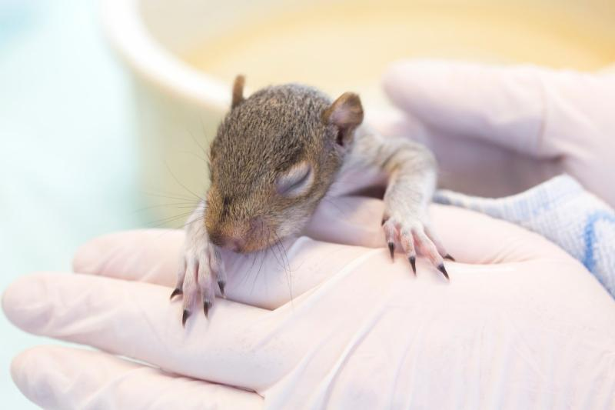
  Photo: Julia Cumes
  With the weather warming up, and Cape Codders getting their gardens going (and inadvertently disrupting nests), this is the time Wild Care sees an influx of baby squirrels. Right now we have over two dozen in our clinic, each needing to be fed between three and five times a day. Their hand fed meals consist of walnut water formula, while salads and nuts are on offer all the time in their cages. We will be keeping the older ones for at least two more weeks before finding wild spots to re-home them.
  Save A Life.
  Donate today by clicking here!
  Donate Items from our Wish List
  A Taste of Spring
  Reserve your seats now for
  A TASTE OF SPRING.
  A Benefit Dinner For Wild Care Cape Cod on MAY 13th
  Join other Wild Care friends at an elegant three course dinner at Harwich's cozy and sophisticated Viera restaurant. Chef Benjamin Porter's cuisine features fresh local ingredients prepared with style and passion.
  Complimentary glass of wine provided by Horizon Beverage and live flute music from Peggy Gerber.
  $100 per person
  Proceeds benefit Wild Care's wildlife rescue and rehabilitation work.
  To reserve: 774-353-6203 or events@wildcarecapecod.org
  Loon Tune
  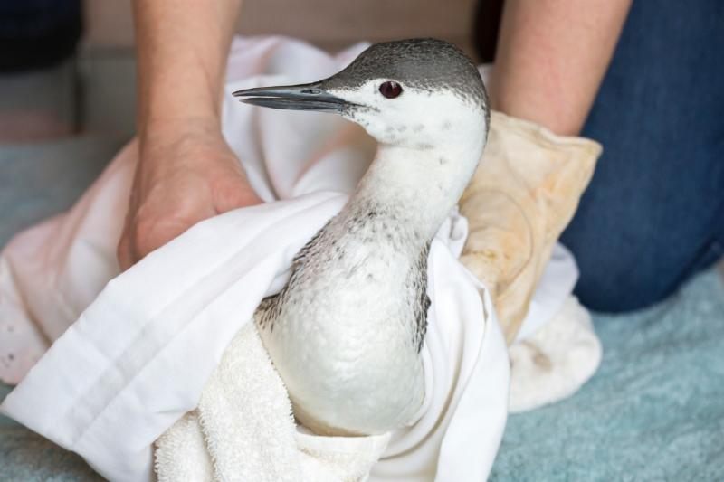
  Photo: Julia Cumes
  Mistaking pavement for water is what we surmise caused this Red Throated Loon to crash land onto a parking lot in Harwich earlier this month. After our staff rescued him, we discovered he had broken toes on one foot and stiff movement in the other. Otherwise, his overall health was good, and has been happily spending hours in our Sea Bird pool. In winter, the Red Throated Loon is a nondescript bird of grey and white plumage, but during the breeding season, it develops a distinctive reddish throat patch, thus its name. Like all loons, its legs are set far back on its body, providing them with excellent propulsion in the water. We are keeping a careful eye on our Loon patient, as it continues to swim and work its damaged legs.
  Want to help? Please consider making a donation today. Click here to go to our Donation page.
  Tale of The Terrapins
  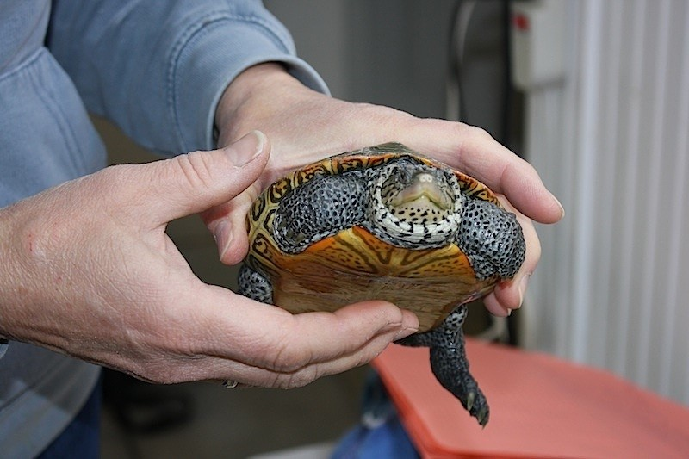
  Photo: Julie O'Neil
  This month we were called on by our colleagues at Wellfleet Audubon to help house and treat a dozen or so Diamondback Terrapins who were part of an unprecedented cold stun stranding. While many were able to be released near warmer waters in Chipmans Cove, the most critical were brought to Wild Care where they received subcutaneous fluids and warm homes. Not every one of them survived, but so far we've been able to return five back to Audubon for release and have several more remaining in our clinic, still recovering.

Wild Care
10 Smith Lane
Eastham, Massachusetts 02642
info@wildcarecapecod.org
508-240-2255

About Wild Care
Since 1994, Wild Care has treated injured, ill and orphaned native wildlife for release back into the wild capable of independent survival, prevented wildlife casualties through public education and counseling, and engaged the community in conservation services through volunteerism.
Wild Care does not charge the public for our services. We accept wildlife regardless of a rescuer's ability to make a donation; and we never compromise quality of care or the dignity of an animal's life for fundraising purposes.



