February 2015 Duck Tales

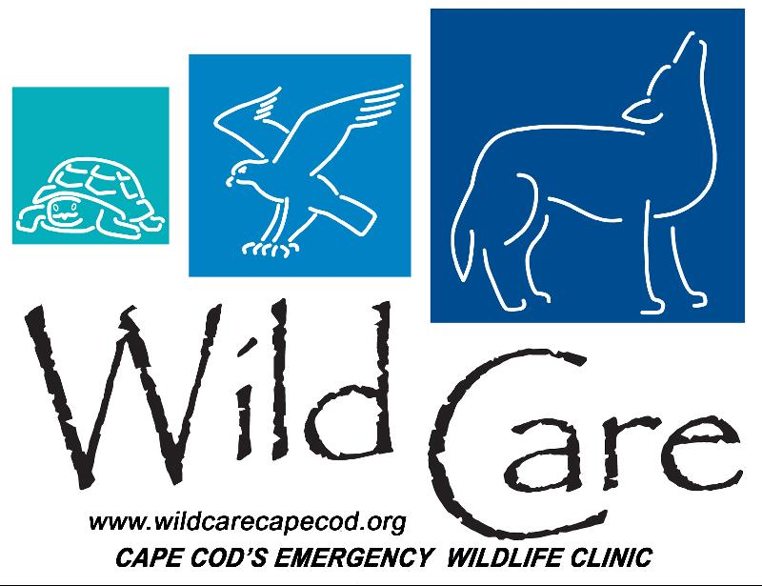

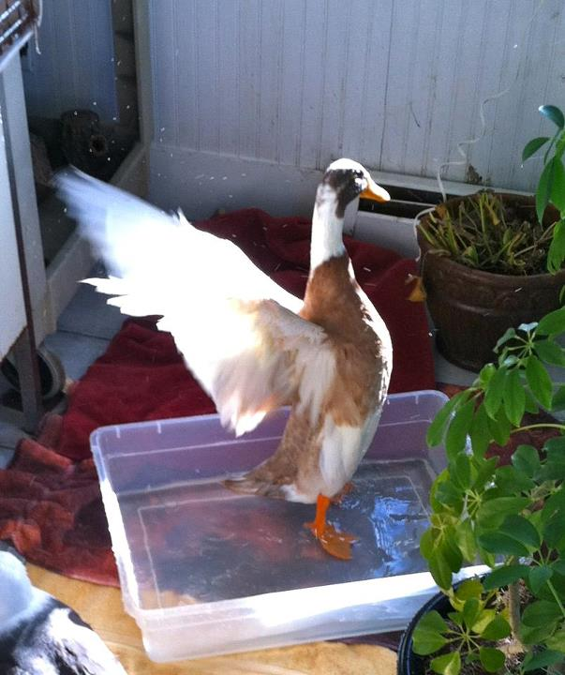
"DUCK TALES"

Wild Care's Monthly E-News

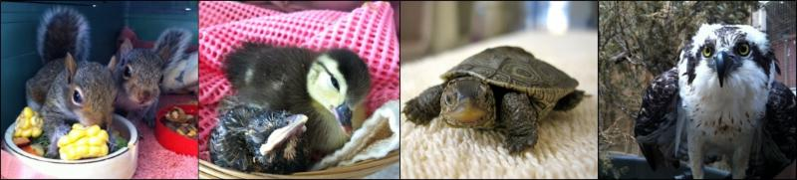

To learn more about Wild Care, visit our web site!
www.wildcarecapecod.org

  Stormy Weather
  We all know how it has been in New England this winter so far ~ record snowfall, frigid temperatures, and icy conditions. While we can take refuge in our cozy homes, the wild birds, reptiles and mammals of Cape Cod have to struggle to survive outdoors. Wild Care has accepted dozens of additional animals this winter, including many sea birds blown ashore by the fierce winds. We currently have 31 patients in our clinic - more than any other month since August. Here are a few stories of some of the visitors who have been treated at Wild Care this month:
  It Takes Two
  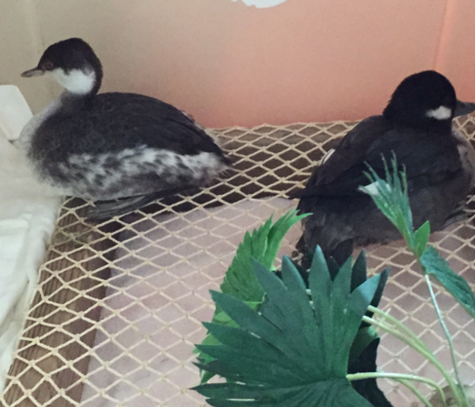
  When these two sea birds came in to Wild Care in early February they were cold, dehydrated and emaciated. The Bufflehead also had a wound on his back. Our animal care team treated the Bufflehead's wound and kept both him and his Grebe friend warm and well-fed. Before we could release them back into the wild we had to ensure they were waterproof, but neither of them seemed to be preening on their own. So we put them together to swim and then into a crate as a pair to stimulate preening and it worked. Our amazing volunteer Swede Plout released both birds in Truro, near where other Grebes and Buffleheads had been sighted. Swede reported that the Bufflehead took off instantly and joined a nearby family of Buffleheads, while the Grebe demonstrated his renewed wing strength by flying far out over the open water towards another flock of Grebes. This happy ending goes to show that even birds need a little help from their friends.
  Wild Roomies
  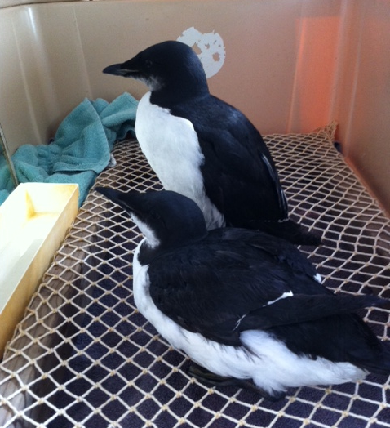
  Two thick-billed Murres arrived at the same time to Wild Care from Eastham and P'Town respectively and each was suffering from coccidia. We have placed them together while they both receive anti-parasitics, and their companionship is keeping them calm while they recuperate.
  Donate Items from our Wish List
  Gone Gannet
  After being discovered on the pavement near Race Point in Provincetown, this adult Gannet spent a good week or so at Wild Care. It had a mouth injury that needed to be treated and as he gained strength he also grew a bit too bold to stay in the clinic. We moved him to the elliptical aviary to get him re-accustomed to the cold weather and then released him at Rock Harbor in Orleans. The water looked freezing to our staff but it suited the Gannet just fine and he took off over the ice toward the sea.
  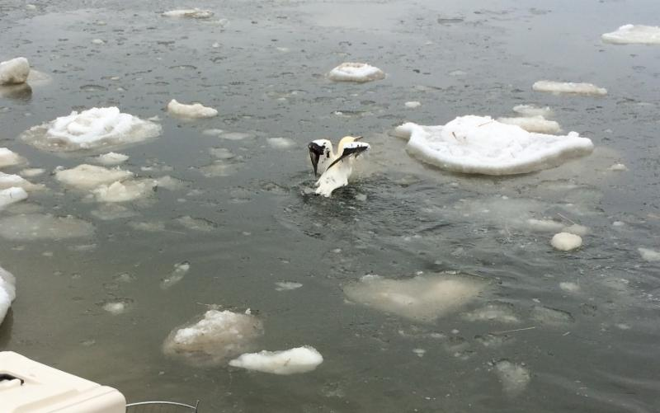
  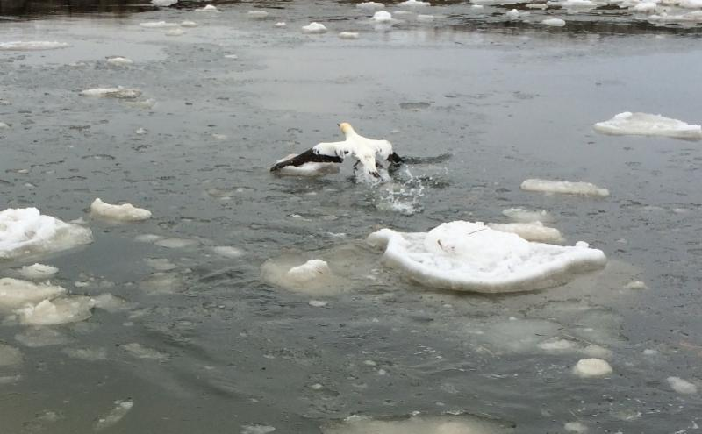
  Thanks to the Moose!
  
  We were honored to be chosen by The Women of The Moose from the Yarmouth Moose Family Center to be beneficiaries of their recent Rummage Sale. The Loyal Order of the Moose is an international organization of men and women dedicated to caring for the young and old, bringing communities closer together and celebrating life. Kristen Seymour, who organized the rummage sale, chose Wild Care because she had brought injured birds to our clinic in the past and loves the work we do on behalf of the wildlife on Cape Cod. So our smaller animals all thank the Moose for thinking of them!

Wild Care
10 Smith Lane
Eastham, Massachusetts 02642
info@wildcarecapecod.org
508-240-2255

About Wild Care
Since 1994, Wild Care has treated injured, ill and orphaned native wildlife for release back into the wild capable of independent survival, prevented wildlife casualties through public education and counseling, and engaged the community in conservation services through volunteerism.
Wild Care does not charge the public for our services. We accept wildlife regardless of a rescuer's ability to make a donation; and we never compromise quality of care or the dignity of an animal's life for fundraising purposes.



