January 2014 Duck Tales – A Year in Pictures
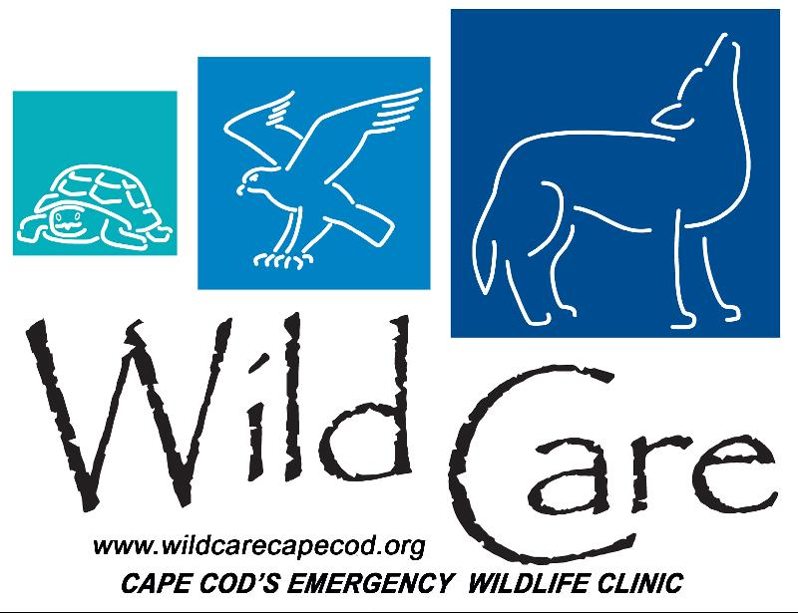

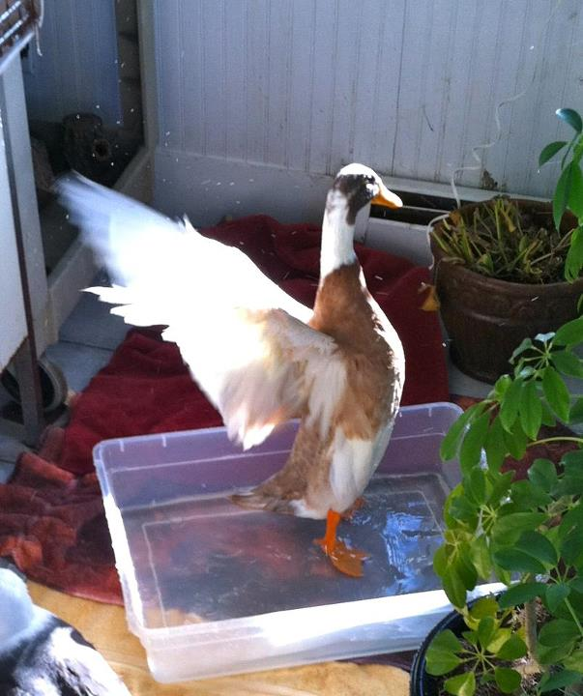 "DUCK TALES"
Wild Care's Monthly E-News

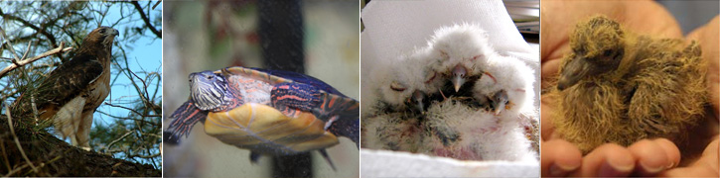

To learn more about Wild Care visit our web site!
www.wildcarecapecod.org

  Donate Items from our Wish List
  January
  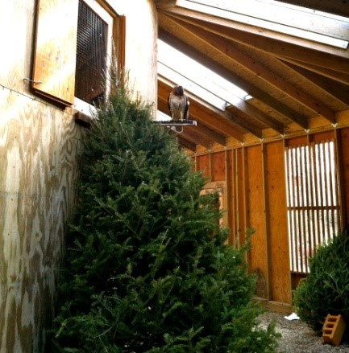
  A Red-tailed Hawk gets a birds-eye view from atop of a Christmas tree in the raptor aviary.
  Dozens of people donated their Christmas trees to adorn our raptor aviaries in response to a wonderful Cape Cod Times article requesting recycled trees for Wild Care. We use trees to create perches and habitats in our aviaries so that the patients experience a natural environment.
  February
  Nemo hit and dropped dozens of seabirds on our doorstep including a Peregrine Falcon, three Razorbills, Dovekies, gannets, murres, Great Black-backed gulls, a Canada Goose and six Atlantic Puffins!
  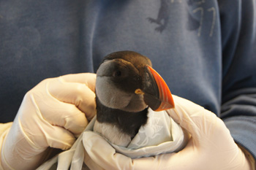
  Atlantic Puffin. Photo by Tyler Piebes
  March
  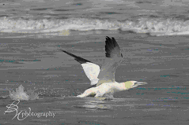
  Northern Gannet. Photo by Betty Wiley
  Released! Dozens of seabirds from the onslaught of February's winter storms were sent back to the sea during the month of March.
  April
  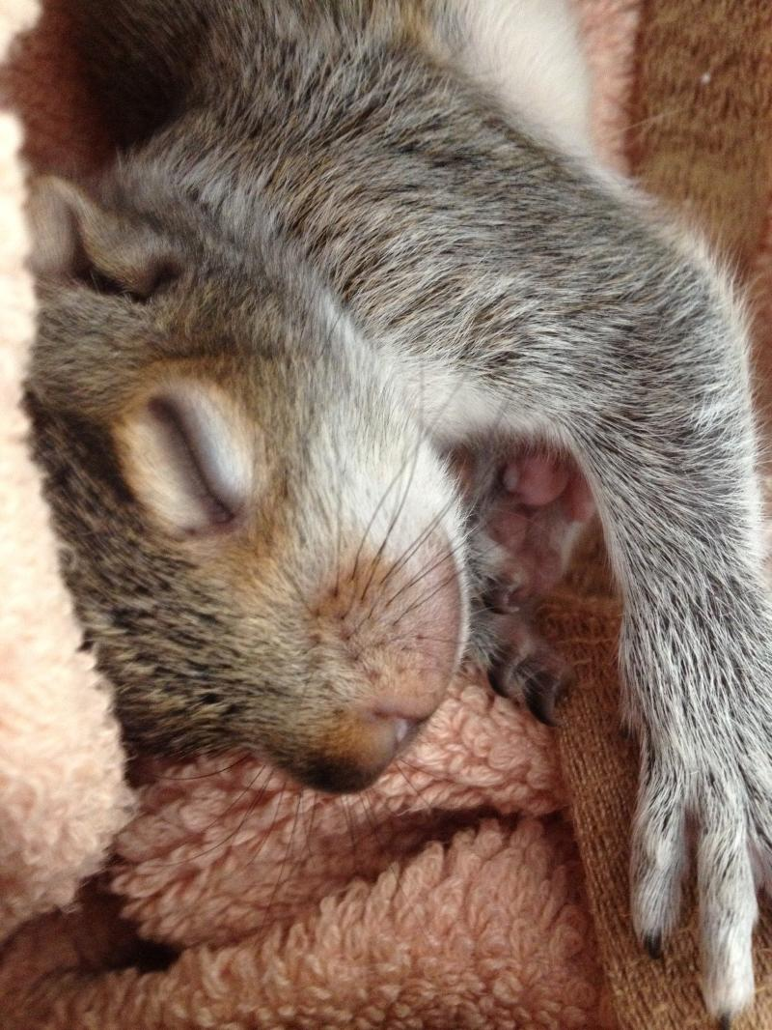
  Orphaned Eastern Gray Squirrel
  Our first Eastern Gray Squirrel arrived on April 10th. In spring of 2013, Wild Care staff were able to return over 20 orphaned squirrels back into their nests! Squirrel parents are the best!
  May
  The first orphaned songbirds of the season arrived. Last spring we successfully released over 30 orphaned songbirds that came to our door.
  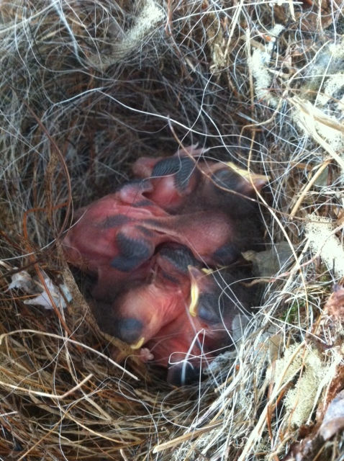
  Our first orphaned Carolina Wrens. Their nest fell from a Lilac bush. Wild Care placed the nest back into the bush but the parents did not return.
  June
  Our 19th Annual Yard Sale at the Harwich Community Center was once again a success, raising close to $5,000 for Wild Care!
  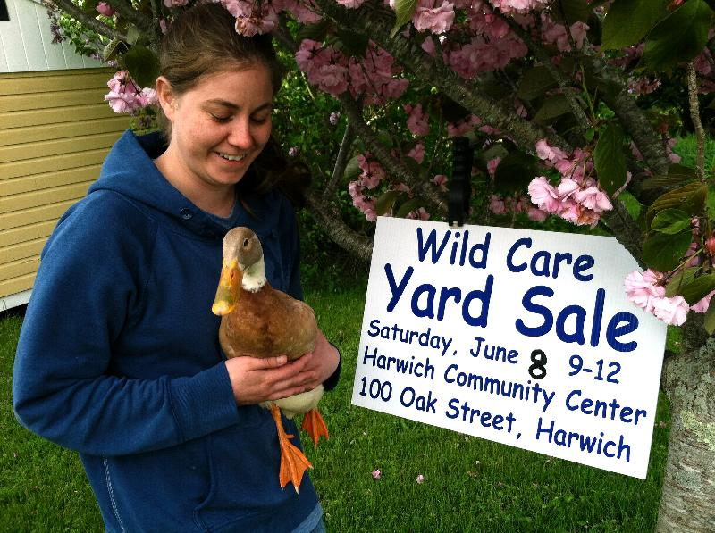
  Wildlife Rehabilitator Andrea Dedekam with Wild Care's mascot "Quackers".
  July
  We received a species of bird that we do not receive very often. A Black-billed Cuckoo!
  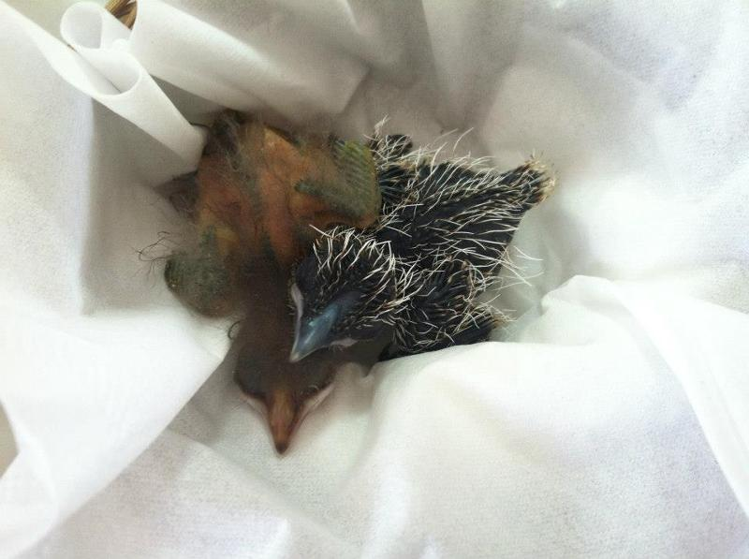
  Black-billed Cuckoo (right) snuggles with a Common Grackle in the incubator.
  This species breeds in Massachusetts but are very secretive. This bird fell from its nest and was found in the road in Eastham weighing only 7 grams! Cuckoos are insectivores and feed largely on caterpillars- even the spiny ones! This little caterpillar eating machine quickly grew up and was released!
  WILD CARE'S
  YEAR IN PICTURES
  Last year, we received
  1,216 animals!
  Here are some highlights from 2013 that we'd like to share
  with you!
  And don't forget to join us for
  Wild Care's
  A Wild Winter Night!
  Saturday, February 8th
  Chatham VFW
  Click here to find out how to purchase tickets!
  August
  We received our first Wood Duckling this month. Wood Ducks get extremely stressed when separated from their siblings. With no other Wood Ducklings around, we placed "Woody" (named by his rescuer) with an American Robin. The pair miraculously bonded.
  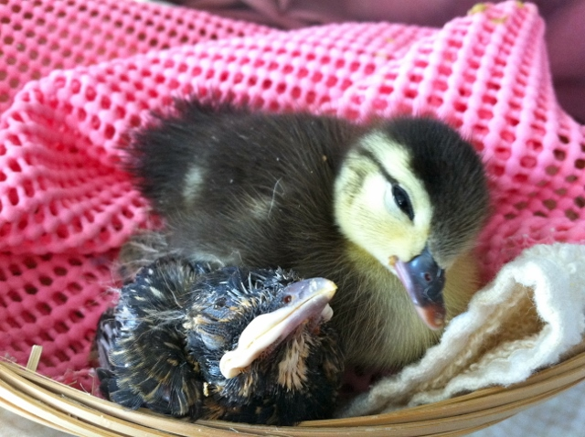
  American Robin (left) with "Woody"
  Later in the month, we received a brood of 14 orphaned Wood Ducks. Woody was an incredible foster parent to them, showing them the ropes... a very special duck!
  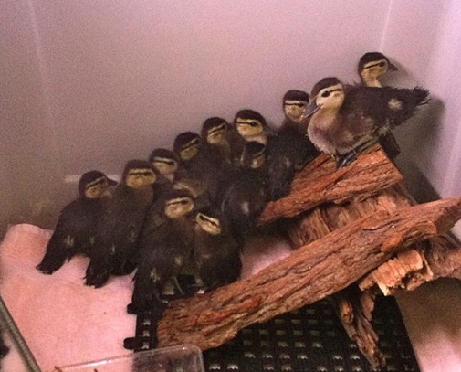
  Woody (right front) shows the new kids the ropes!
  September
  A very busy month at Wild Care. We received 56 patients in less than two weeks. From songbirds, opossums, hawks to turtles, Wild Care was bustling with activity!
  After a Common Snapping Turtle was hit by a car and mortally wounded, she was brought to Wild Care where staff discovered she had eggs. The eggs were surgically removed and delivered to Wellfleet Bay Wildlife Sanctuary for incubation. Three months later, 25 baby snapping turtles hatched!
  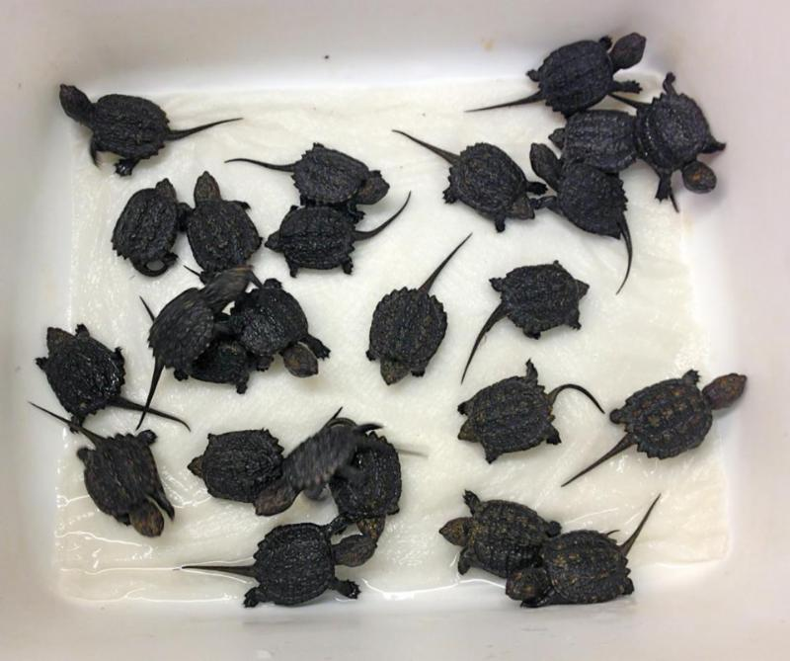
  Baby Snapping Turtles hatch after their eggs were removed from their mother who was hit by a car.
  October
  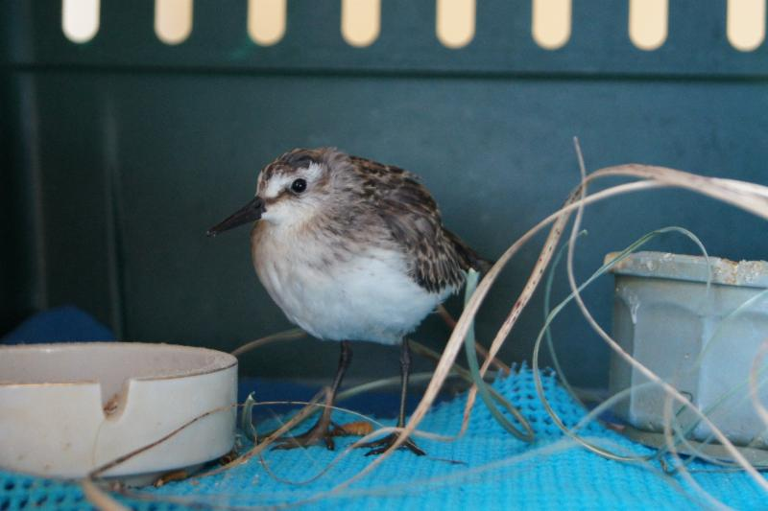
  A Semipalmated Sandpiper finds a permanent home in the New England Aquarium's Shorebird Exhibit.
  Photo by Tyler Piebes.
  Wild Care received a non-releasable Semipalmated Sandpiper with a shoulder injury. We collaborated with the New England Aquarium in Boston, and the sandpiper was transferred there and is currently an educational bird in their Shorebird Exhibit. More recently, Wild Care transferred a non-releasable Common Tern to the aquarium. He is also in the exhibit. Please stop by and visit them!
  November
  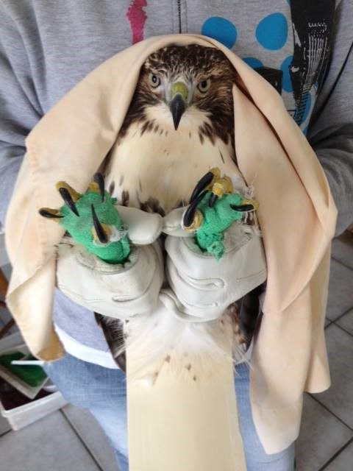
  Wild Care received a Red-tailed Hawk that was hit by a car. The bird had a soft-tissue injury to one of his wings as well as a foot infection. With daily spa treatment, antibiotics and TLC from staff, this bird made a miraculous recovery and was released!
  December
  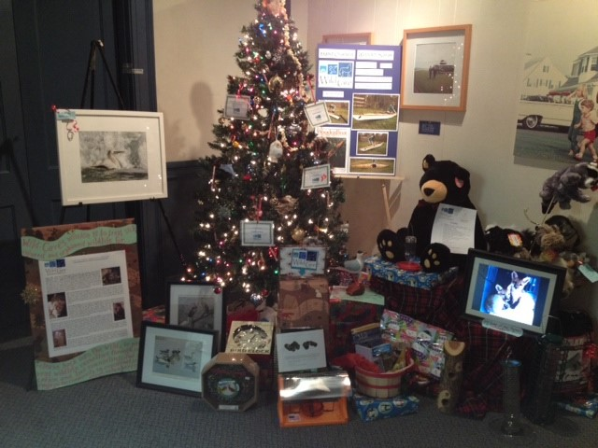
  Wild Care participates for the first time ever in the Spectacle of Trees! Held in December at the JFK Library by the Cape Cod Charitable FunRaisers, 17 organizations displayed trees that were up for raffle for $10 Tree Bucks. The winner gets to take home the entire tree and all the gifts! Winners Alice and Mike Fabia of Harwich were absolutely delighted to win Wild Care's beautiful tree!
  Wild Care
  10 Smith lane
  Eastham, Massachusetts 02642
  info@wildcarecapecod.org
  508-240-2255

About Wild Care
Since 1994, Wild Care has treated injured, ill and orphaned native wildlife for release back into the wild capable of independent survival, prevented wildlife casualties through public education and counseling, and engaged the community in conservation services through volunteerism.
Wild Care does not charge the public for our services. We accept wildlife regardless of a rescuer's ability to make a donation; and we never compromise quality of care or the dignity of an animal's life for fundraising purposes.

