July 2015 Duck Tales

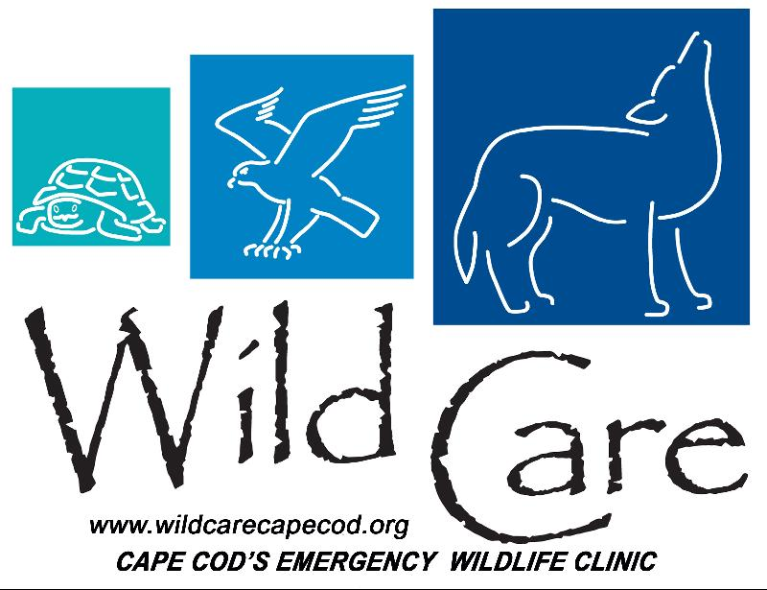

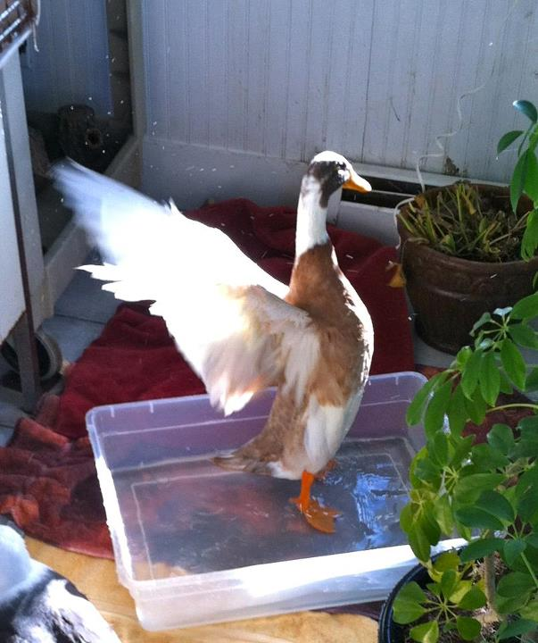
"DUCK TALES"

Wild Care's Monthly E-News

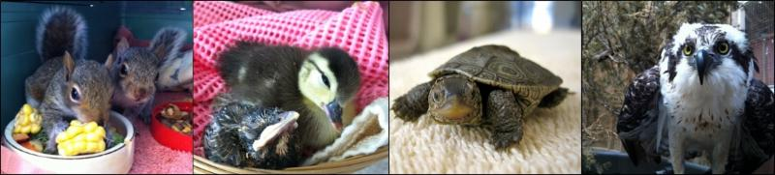

To learn more about Wild Care, visit our web site!
www.wildcarecapecod.org

  Mini Cooper
  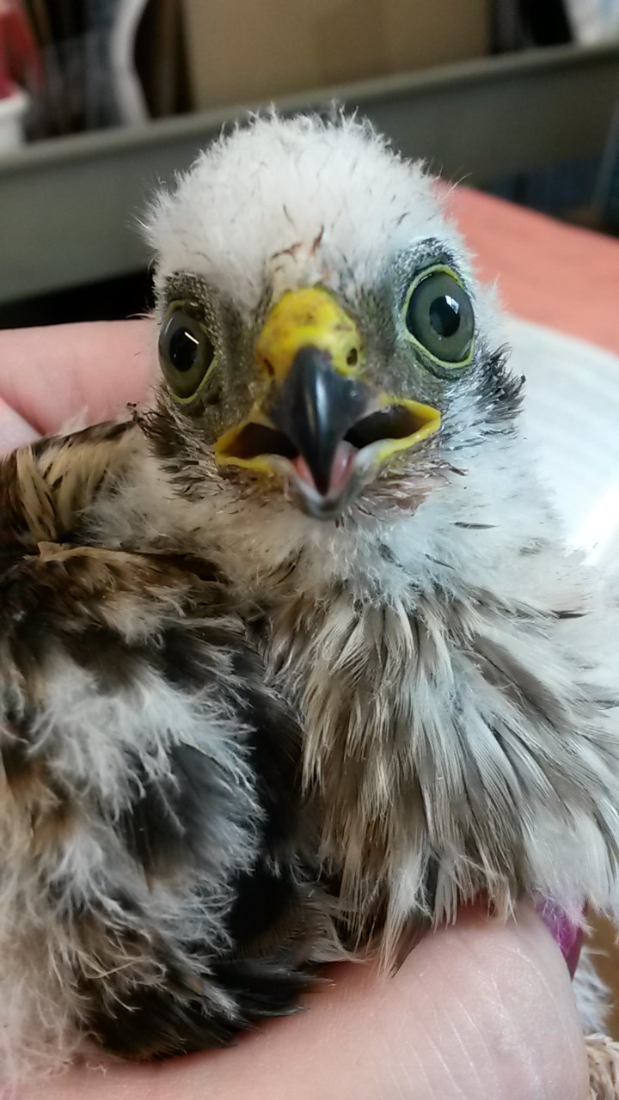
  This nestling Cooper's Hawk was discovered on the ground by a runner near Nickerson State Park in Brewster, who brought it into our clinic. The hawk was uninjured and in pretty good health. We collaborated with experts Bob Prescott and Norm Smith from Mass Audubon for accurate identification, as many nestling hawks are very similar. He is doing well, eating the mice we offer him and is actually fierce and quite feisty! We are looking forward to reuniting him with his parents or re-nesting him into a foster nest.
  Click here to make a donation to help him and all the other animals cared for daily.
  Rockin' Robins
  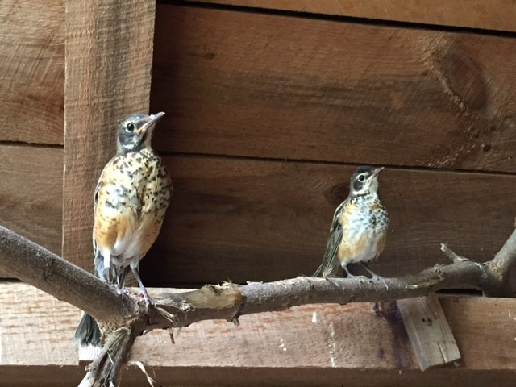
  A month ago, a resident of Dennis Port brought in three baby robins that had fallen from their nest. Two of them had deep lacerations on their backs - possibly a result from another animal's attack. Wild Care's wildlife rehabilitator Amy Webster, assisted by intern Aelish Aoki, treated the wounds, binding the lacerations back up with a medical-grade adhesive known as Vetbond. After some healing time, the birds were then moved to our baby bird barn, where our team of dedicated volunteers fed them at their regular schedule of every 20 minutes, for 12 hours a day. Once they grew stronger and bigger, they were moved to our outdoor songbird aviary, joining their uninjured sibling and five other fledging robins. We are watching closely to see when the birds become completely self-feeding and not reliant upon us to administer food. They are eating worms, and their fruit plate has been emptied each day, so we are confident that very soon they will be able to be released.
  Donate Today to Help Animals in Need! Click Here!
  Racer X
  A black racer snake was discovered tangled in garden mesh in a yard in Truro. Our volunteer rescuer Swede Plout delivered him to us, and we cut away the mesh, which had become entangled in his scales. The snake was otherwise in great health, so Swede happily returned him to Truro so he could slither away unfettered.
  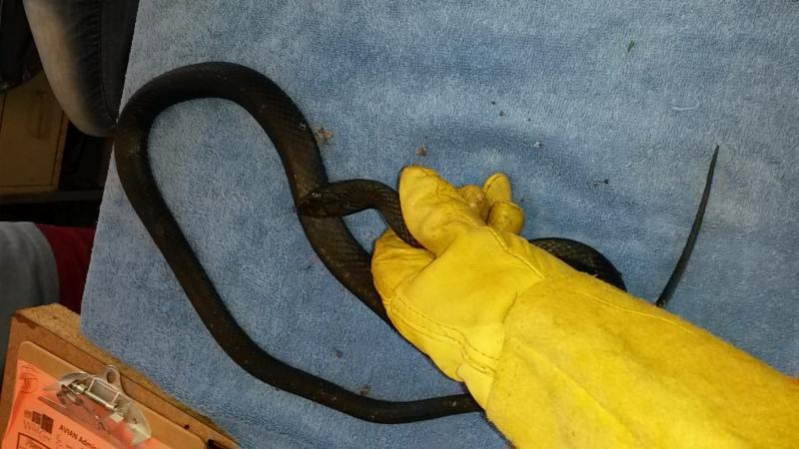
  Another reminder to our Wild Care friends with gardens ~ the mesh fencing you use might be hazardous to wild animals, so please always keep a look out in your yards for animals in distress ~ and give our Helpline a call at 508-240-2255!
  Donate Items from our Wish List
  Save the Date: 9/11/15
  DINE OUT AT ARNOLD'S
  Once again Wild Care friend Nate Nickerson and his wonderful team at Arnold's Lobster & Clam Bar in Eastham are donating a day's profits to Wild Care!
  So on Friday September 11th, head up to 3580 Route 6 in Eastham and enjoy their delicious seafood, any time from 11:30am to 9pm. All the net proceeds will be coming to us! It is an incredibly generous display of support from Arnold's and we encourage all of you to visit that day if you can!
  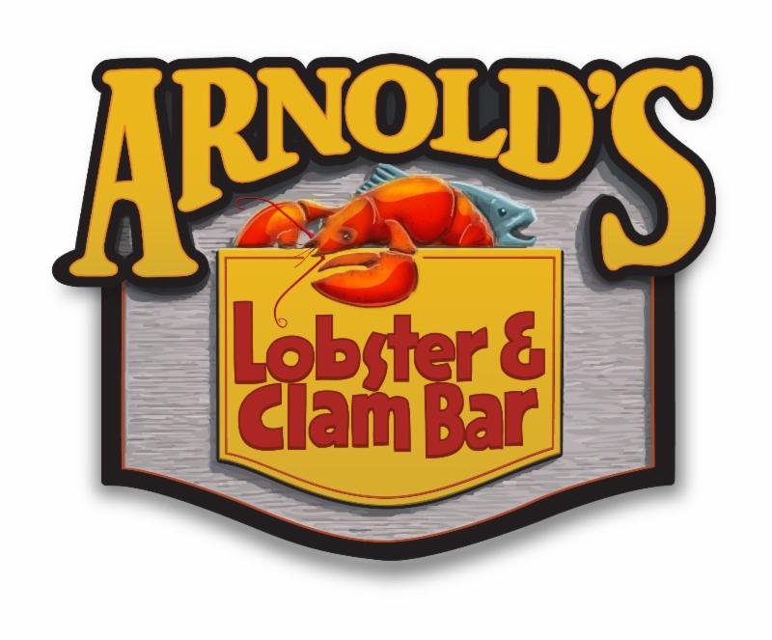
  More Welcomes to our Summer Interns
  Wild Care has two more summer 2015 interns that we are proud to introduce to you. We appreciate their hard work and dedication to our animals!
  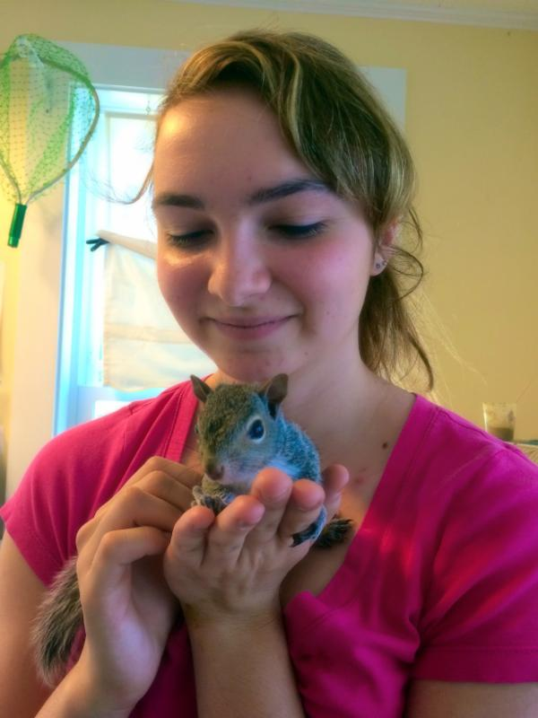
  MacKenzie making friends at Wild Care.
  Mackenzie Dugas had not been to the Cape since she was a little girl before joining us this summer at our wildlife center. An Animal Care major at Becker College in Worcester, MacKenzie is staying at the Hostel International in Eastham where she is meeting a lot of interesting visitors from around the world. She says that at Wild Care "the people are great!" and the best experiences are when animals get released. "That is pretty cool to see," she says.
  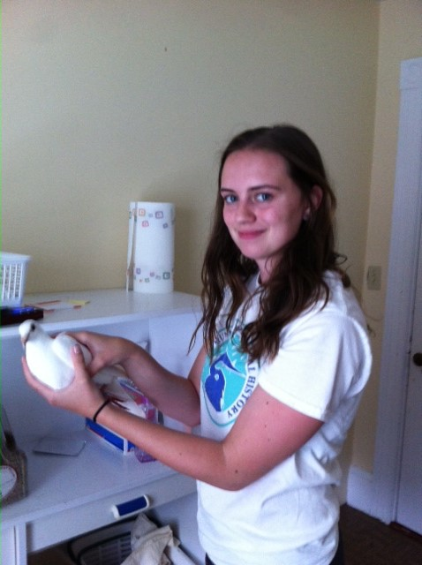
  Meg Carr about to weigh a pigeon patient.
  A native of Brewster and 2013 graduate from Nauset High, Meg Carr is heading into her junior year at University of New Hampshire where she is studying marine biology. She is enjoying her work here at Wild Care and says one of her favorite things is caring for the baby squirrels. "I just love them!" Meg says.

Wild Care
10 Smith Lane
Eastham, Massachusetts 02642
info@wildcarecapecod.org
508-240-2255

About Wild Care
Since 1994, Wild Care has treated injured, ill and orphaned native wildlife for release back into the wild capable of independent survival, prevented wildlife casualties through public education and counseling, and engaged the community in conservation services through volunteerism.
Wild Care does not charge the public for our services. We accept wildlife regardless of a rescuer's ability to make a donation; and we never compromise quality of care or the dignity of an animal's life for fundraising purposes.

