June 2015 Duck Tales
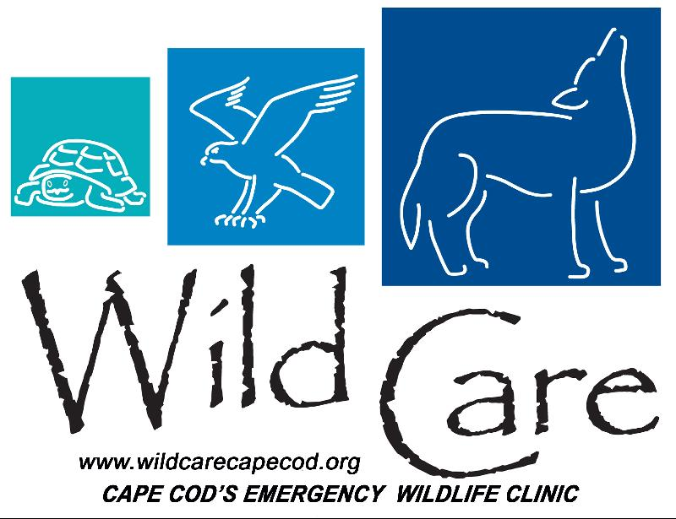

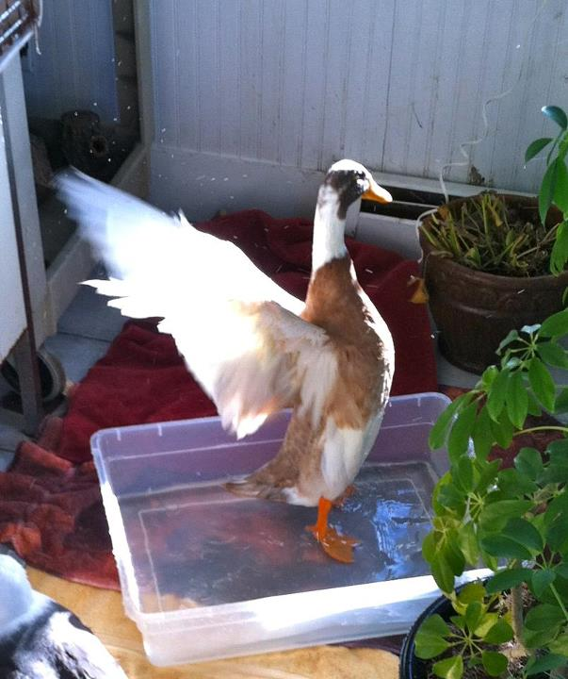
"DUCK TALES"

Wild Care's Monthly E-News

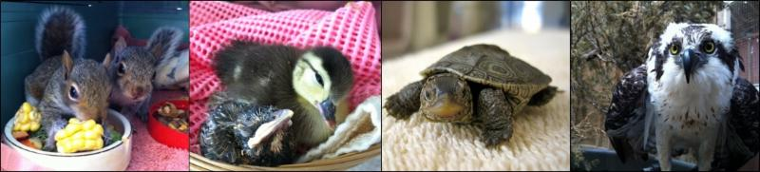

To learn more about Wild Care, visit our web site!
www.wildcarecapecod.org

  Welcome to our Summer Interns!
  It's summer, so that means we have a great group of hardworking interns at Wild Care. This month we are happy to introduce you to Emily and Aelish.
  Emily Gross is a Captive Wildlife Care & Education major at Unity College in Maine. She was raised in Texas, but has been coming to the Cape "since I was in diapers", she says, and the thing she likes the most about interning at Wild Care is "how hands on it is. I didn't expect to learn to do so much."
  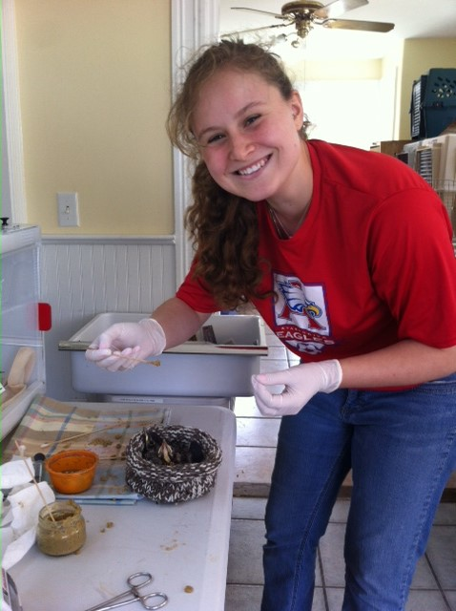
  Emily Gross feeding baby birds
  Scarsdale New York native Aelish Aoki studies biology at Elon University in North Carolina and, like Emily, has been summering on the Cape with her family "since as long as I can remember." She appreciates that she can work with so many different kinds of animals at Wild Care, not only the baby birds, but snapping turtles, turkeys and opossums too.
  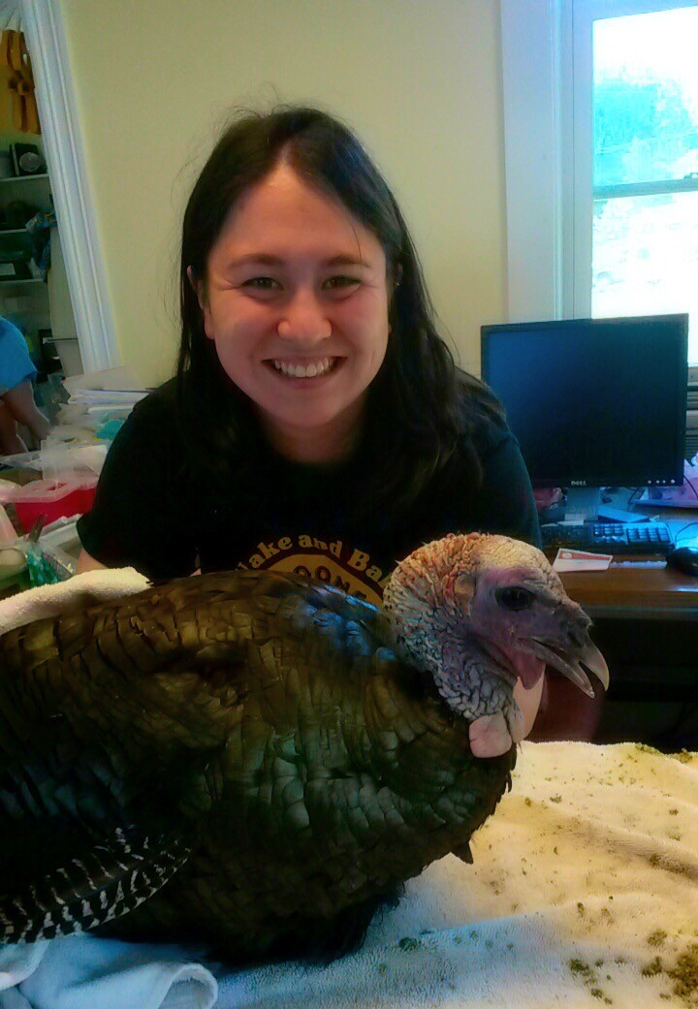
  Aelish Aoki helping with an injured wild turkey
  Wild Care appreciates their passion, dedication and positive attitudes!
  Who Are You?
  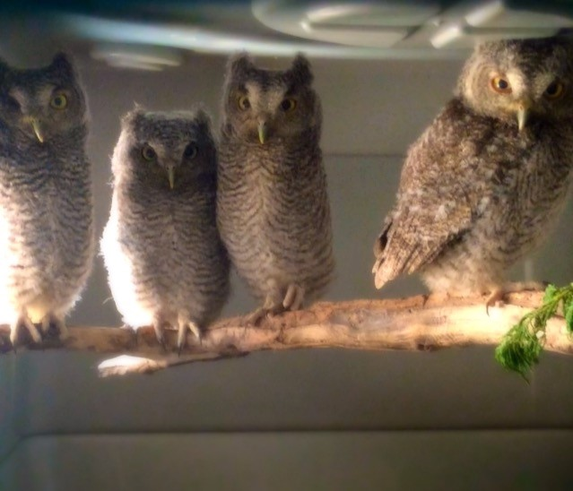
  A little over a week ago, a visitor to Nickerson State Park in Brewster found four baby Screech Owls near a fallen tree. They were covered in woodland debris, with neither a viable nest nor any evidence of parents nearby. When they were bought to Wild Care they were evidencing the tell-tale signs of dehydration ~ sunken eyes and thick throat mucus. As soon as we administered Pedialyte they perked right up and have been steadily improving ever since. To replicate how a mother owl would feed, we have been offering mice in turn to each of the babies. Already two of them have been able to feed themselves from their bowl, and all four have fledged ~ with owls this is often referred to as "branching." They are beautiful and fascinating birds and we are happy to watch and facilitate their wonderful progress.
  Possums on the Patio
  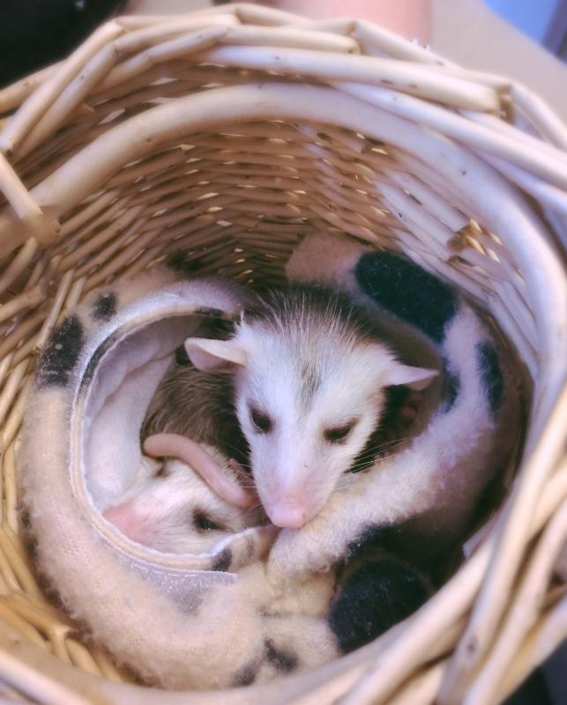
  A homeowner in Yarmouth discovered two juvenile opossums wandering onto their patio, first one and then the other a couple of days later. Noticing that there was no mother opossum, they brought both siblings in to Wild Care, who proved to be a boy and a girl. We hydrated them and then began tube feeding, as they do not suckle like squirrels and other mammals. Once they grew a bit we progressed to chopped up veggies and fruit and finally some of the proteins these carnivores eat: mice, fish and egg. We moved them first to the barn then into the large outdoor mammal cage, where they have been given nest building materials. They are getting stronger and bigger and we were pleased to see that they proved their natural ability to survive storms when despite the torrential rains over the past week, they have kept themselves warm and dry.
  Donate Items from our Wish List
  Thank You!!!
  Thank you to everyone who donated, volunteered and shopped at our 21st Annual Wild Care Yard Sale on June 13th ~ It was a great success and we really appreciate all your support. And a very special thank you to our new Yard Sale coordinator Jan Raffaele who took over the reins from longtime coordinator Joyce Leary and did a wonderful job!
  Thank you to the Penny Harvest students of Ezra Baker Elementary school! For the second year in a row, the 2nd and 3rd grade students of the "philanthropy round table" group at this Dennis primary school chose Wild Care as one of their beneficiaries of their "Penny Harvest", an organized program in which the entire student body helps raise funds for local charities by collecting spare change from their families, friends and neighbors. We are so grateful, not only for the donation of $302, but also to Ellen Flanagan, the Dean of Students at Ezra Baker School, for inspiring young people to participate in community service this way.
  Make Way for Cygnets
  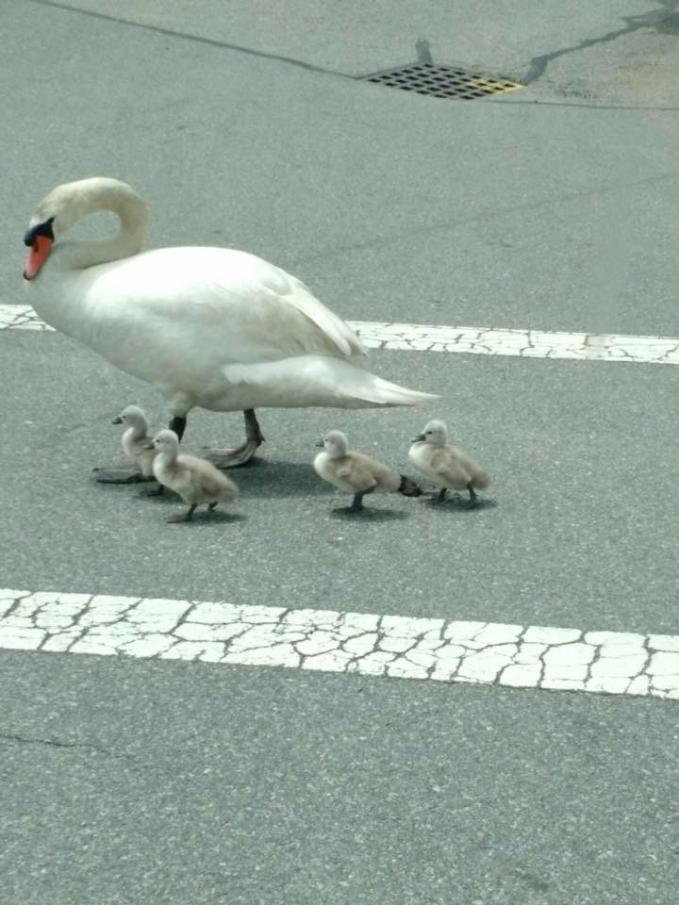
  With a little help from our friends in the Orleans Police Department, Wild Care wildlife rehabilitator Amy Webster and Wild Care volunteers Jean and Steve Hliva moved and guided this out-of-their-element swan family from the parking lot of Friends Market down to nearby Boland pond. Amy netted the father swan and then carrying him, slowly led the way as the mother and cygnets followed. Jean and Steve guarded the family from behind, as Officers Boucher and O'Connell ensured that vehicular traffic gave way for the water fowl family. Once the entire parade was out of harm's way and close to the pond, the Wild Care team retreated as the swans returned to their natural habitat.
  You can see a brief video of the swans on the Orleans PD Facebook page: https://www.facebook.com/orleanspolice/videos
  Mark your calendars for the "Sip n Shop" event on July 9th from 1pm - 5pm at J. McLaughlin on Main Street Chatham ~ Wine & Shopping for a good cause! 15% of sales during that time will be donated to Wild Care.
  A Letter...
  Every day Wild Care relies on the dedication and devotion to wildlife of our volunteers. Recently one of them, Martyne Kostka, brought us some house finches. Here is her letter to us about it:
  "About 6:15 AM on the cold morning of Monday June 15th, I received a call from a friend distressed about two tiny baby birds on her porch. They had fallen out of their nest the night before, which had been built in a door wreath and disturbed by furniture movers (unbeknownst to my friend). I drove right over and took the two huddled babies immediately to Wild Care (the nest was torn and upside down in the wreath). As always I received a warm and comforting greeting from Jennifer. After examination of the babies she fed them pedialyte and put them in an adorable homemade felt nest and into the warmth of the incubator where they recovered for several hours.
  I went back to my friend's house and retrieved the wreath and the tattered nest and took them back to Wild Care. We took what was left of the original nest and put it inside a small basket which Jennifer secured to the wreath. I was amazed by Jennifer's perfection in "hollowing out" just the perfect space for the tiny house finch babies. She placed them in their "new/old" nest and I took the wreath, nest and all, back to my friend's house. My friend and I placed the wreath back on her door with towels below, just in case they fell out again. My friend kept watch and after a couple hours both parents were back feeding their babies!! As of six days later, the babies were still being fed in their awesome nest and all was well.
  The folks in our area are so blessed to even have a place, much less a wonderful place, to take injured and orphaned birds for treatment or to be raised until releasable. And Wild Care is so blessed to have Jennifer's compassionate, faithful, experienced and skilled expertise. One small story. One big success. Two house finches more in East Orleans.
  Thank you Wild Care."
  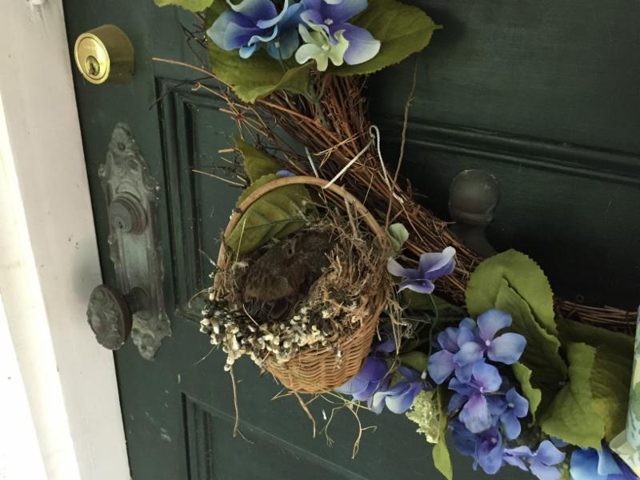

Wild Care
10 Smith Lane
Eastham, Massachusetts 02642
info@wildcarecapecod.org
508-240-2255

About Wild Care
Since 1994, Wild Care has treated injured, ill and orphaned native wildlife for release back into the wild capable of independent survival, prevented wildlife casualties through public education and counseling, and engaged the community in conservation services through volunteerism.
Wild Care does not charge the public for our services. We accept wildlife regardless of a rescuer's ability to make a donation; and we never compromise quality of care or the dignity of an animal's life for fundraising purposes.

