May 2014 Duck Tales
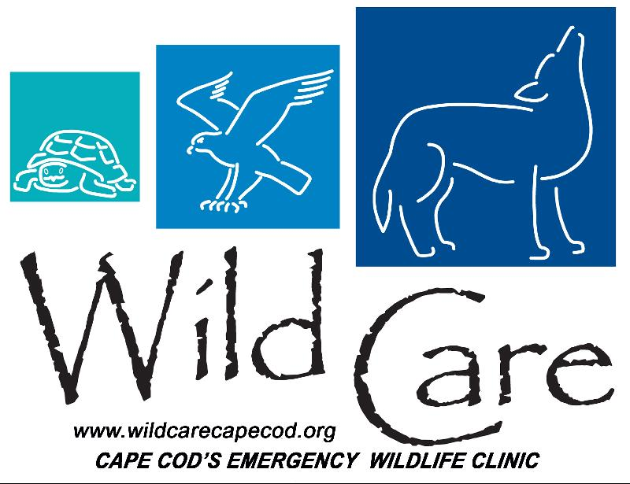

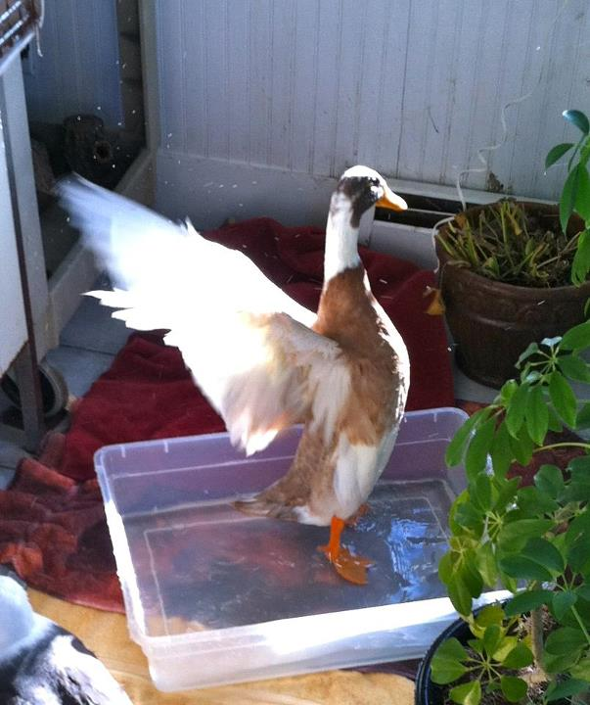 "DUCK TALES"
Wild Care's Monthly E-News

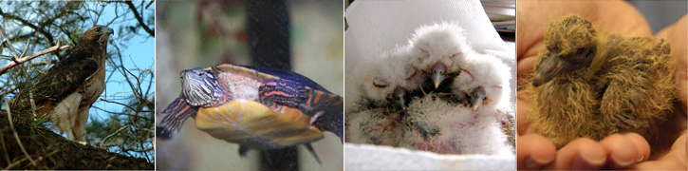

To learn more about Wild Care, visit our web site!
www.wildcarecapecod.org

  Donate Items from our Wish List
  Meet Our New Peeps!
  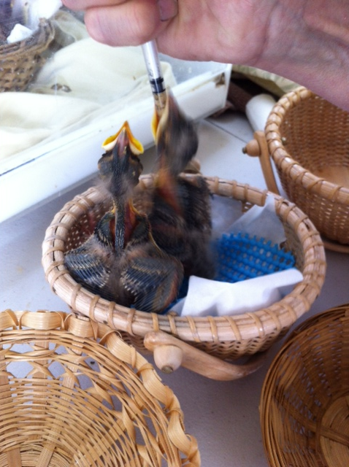
  This year's baby birds have started coming to Wild Care...we have house finches, wrens, robins and cardinals so far ...and they are all looking for a meal!
  We rely on our many dedicated volunteers to help us with feeding the baby birds every 20 minutes from 6am - 6pm. Its a labor of love for all of our trained assistants. Thank you!
  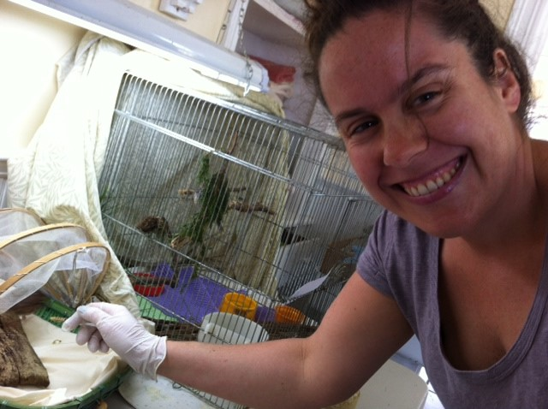
  Volunteer Becky Alexander is spending her second summer as a "baby birder"
  While some avian babies need to come to Wild Care for treatment and care (naked birds without feathers, or those injured by pets or a fall), remember during baby bird season, it is normal to see young birds on the ground, apparently unable to fly. Fledglings have fully developed legs, and are able to hop and jump but are still flightless. Sometimes they will open their mouths when approached by humans. Do not feed or handle these birds. Generally mom is very close by, and if you observe from an indoor vantage point for an hour or so, she will visit her fledglings. Mom (and Dad) will spend a great deal of time away from the nest, so do not assume they have abandoned it. Watch for three hours from an indoor vantage point to gauge what is going on before you intervene.
  Don't Forget Our Yard Sale!
  
  Saturday June 14
  9am - 12pm
  Harwich Community Center
  100 Oak Street, Harwich
  Have items to donate?
  Please bring clean, usable, and priced items to the Harwich Community Center on Friday, June 13 between 1-6pm.
  Questions or interested in volunteering?
  Please call Joyce at 508-394-4364.
  There's a New Way YOU Can Help Wild Care!
  Become a Wild Care sustainer today!
  Help Wild Care year round by pledging a monthly gift.
  To make a monthly donation, click here to go to our Paypal donation page and check "Make This Recurring (Monthly)"!
  
  Or click here to download our "Become A Sustainer" donation form. For assistance, please call our Office Manager Cristalyn Searles directly at 508-240-2255.
  Hoot-enany!
  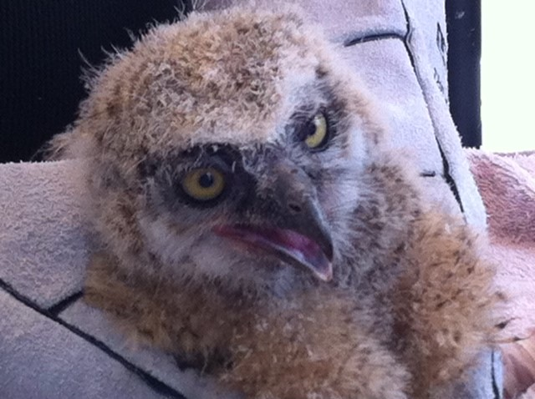
  Wild Care has had a few owl visitors over the past month. Volunteer rescuers dropped off two baby Great Horned Owls, both of whom had fallen from different nests.
  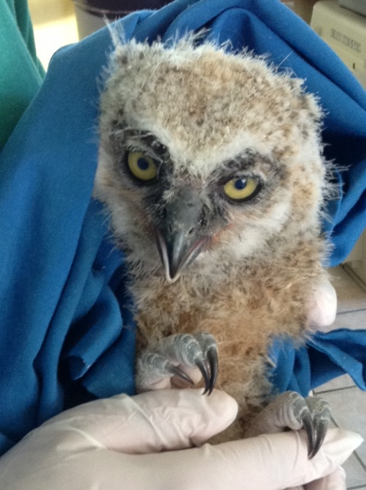
  After examining, feeding and tending to them both, we were able to successfully release them. We were able to return one to its original nesting site in Chatham since a helpful and observant resident noticed a parent in that area, looking for the missing baby to rejoin its siblings. Happily, we could reunite that owl family.
  The other baby was found on the ground in Truro. We searched for a nest to no avail and after tending to him at our center, we relocated him with the assistance of Blue Hill Trailside Museum to an area with active owl nests. Owls tend to take in stray juveniles and raise them as their own, and that is what happened with our owl orphan!
  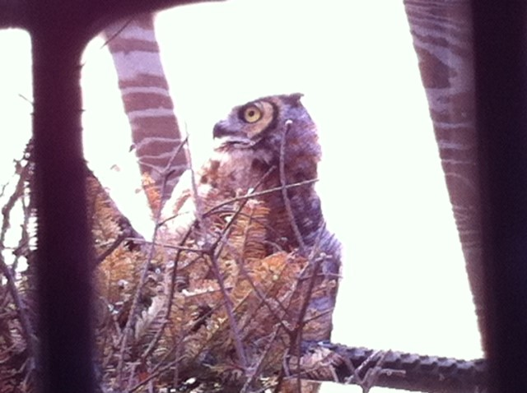
  We had yet another happy ending with an adult Great Horned Owl that our team rescued from a marsh in Orleans. He was sick, most likely from ingesting rat/mouse poison, and bleeding internally as evidenced from his sinuses. With a steady stream of vitamins K & B, and some tender loving care, he has moved to our elliptical aviary where he is clearly improving. He is acting very owly - aggressive and territorial - which in a person might be unpleasant but in an owl is an excellent sign of health!
  Thank You!!
  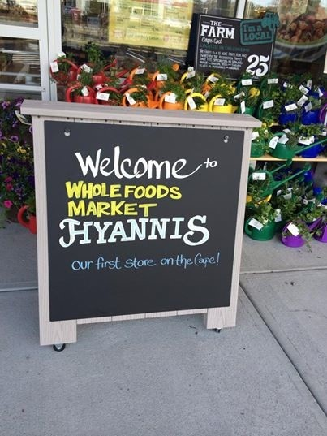
  Thank you again to WHOLE FOODS MARKET HYANNIS for making Wild Care one of its Opening Day beneficiaries. We had a great time meeting some of the hundreds of shoppers on May 14th and sharing some information about Wild Care. The store is beautiful and features lots of locally sourced products. It’s a great place to support the farmers, fishermen and organic purveyors on Cape Cod. And thank you to everyone who came out and shopped to support Wild Care!
  It's Getting Pretty Squirrely Here!
  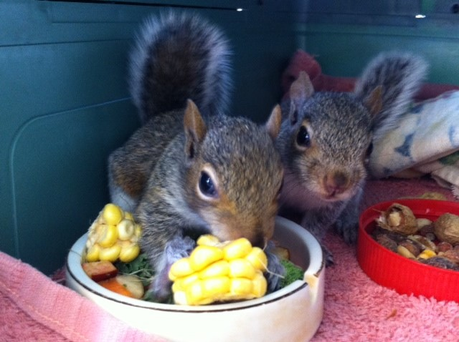
  Wild Care has over two dozen little squirrel friends so far this May, with ten of them already moved to one of our outdoor mammal cages, getting ready for their big day: release back to the wild.
  We still have fourteen others in our indoor infirmary being fed and cared for. These little guys are curious and scrappy and keep our staff entertained with their antics. But don't forget: as cute as they are, squirrels should never be kept as pets.
  If you find squirrel babies on the ground, and they are unresponsive, have cuts, or are following you or your pet, they are not under the care of their mother any more. After 2 or 3 days on their own, they will become cold, dehydrated, very weak, docile, and possibly have fleas. They will not survive without medical attention from Wild Care. Give us a call first at 508-240-2255 and we can instruct you what to do next to help save these adorable little mammals.
  Wild Care
  10 Smith lane
  Eastham, Massachusetts 02642
  info@wildcarecapecod.org
  508-240-2255

About Wild Care
Since 1994, Wild Care has treated injured, ill and orphaned native wildlife for release back into the wild capable of independent survival, prevented wildlife casualties through public education and counseling, and engaged the community in conservation services through volunteerism.
Wild Care does not charge the public for our services. We accept wildlife regardless of a rescuer's ability to make a donation; and we never compromise quality of care or the dignity of an animal's life for fundraising purposes.

