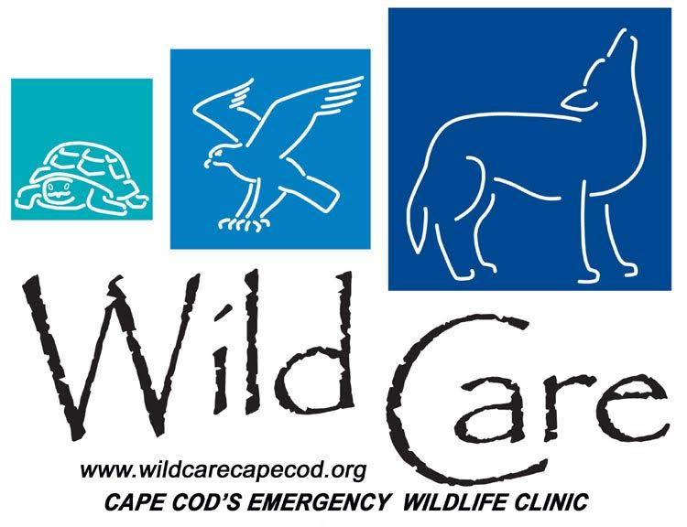
Wild Care, Inc. // 508-240-2255 10 Smith Ln. Eastham, MA. 02642 wildcarecapecod.org volunteer@wildcarecapecod.org
2019 VOLUNTEER APPLICATION
WILDCARE, Inc. is an independent, emergency wildlife clinic that is involved in the rescue and rehabilitation of injured, ill, and orphaned wild animals. We intake approximately 1000-1500 animals every year, and rely heavily on our volunteer team to help with daily operations. Our volunteers are a necessity to the success of our organization, and we seek caring people who are reliable, respectful, and trustworthy. The admitted wildlife brought to our door are highly stressed and need time to heal, so we also seek understanding people who will provide a quiet, and respectful environment for them. Volunteer participation is key to all of our programs to help wildlife.
We are reviewing applications continuously and will notify you if your availability and experience suit our needs. Wild Care volunteers must be at least 18 years of age, and must have an up-to-date Tetanus vaccination. (Ages 16-17 are accepted for the Baby Bird program, with a partner over the age of 18.) Be aware that this is not an opportunity for individuals primarily interested in photography, handling, or personal, repetitive contact with wildlife. Unlike zoos, museums, and aquariums, the native animals we accommodate are not for display, fundraising, educational, entertainment, or training purposes. They are here to recover from being orphaned, injured, or ill, and are intended to be returned to the wild.
Date submitted:
Name:
Mailing Address:
Home Phone: Cell Phone:
Emergency Contact- Name and Number:
Email Address:
Availability: circle Part-Time Resident Year-Round Resident
Preferred day(s) of the week: S M T W Th F S
Time Preference(s): 6am-9am (BB program only) 9am-12pm 12pm-3pm 3pm-6pm
Age Range: circle 16-17 18-25 26-35 36-45 46-55 56-65 66-75 75+
When was your last Tetanus injection? (*required)
Have you had pre/post rabies vaccinations? If so, when? (not required, but helpful)
Can you provide proof of immunization and/or titer records?
How did you hear about Wild Care?

Why are you interested in volunteering at Wild Care?

Please circle the volunteer programs that interest you the most (*please see descriptions on the last page*):
Baby Bird Program (Summer only) Clinic Program Rescue/Transport Program Events Program Fundraising Program

Have you ever been convicted of a felony? If so, explain.

Have you ever been convicted for possession of a narcotic (IE Heroin, Oxycodone, Morphine)?

Are you applying to volunteer here for community service for court? If so, explain.

Would these volunteer hours be for school/projects? If so, explain. Please note we require a minimum commitment of 6 months (only Summer for baby birds).

Have you volunteered here or elsewhere before? If so, where/when/duties?

Have you ever worked with wildlife before? If so, describe your experience.

Do you currently hold a State/Federal Wildlife Rehabilitation Permit?

By its nature, wildlife rehabilitation centers can expose people to parasites, bacteria, zoonotic diseases, injuries, etc. Is this a concern to you?

Please describe your feelings about the euthanasia of wildlife that is not healthy enough to be released back into the wild.

Do you have any previous office/administrative experience?

Do you have any previous experience working with nonprofit organizations?

When is your birthdate?

What are your hobbies/areas of interest?

What are your greatest strengths and weaknesses?

What are some tasks you would enjoy doing?

Are there any tasks that you would prefer not to do? Please explain.

Do you have any health concerns that Wild Care should be aware of? (IE allergies, seizures, prone to fainting at the sight of blood, etc) Please explain.

Is there anything else about yourself that you would like us to be aware of?

When would you be available to begin your volunteer position?

WILD CARE’S VOLUNTEER OPPORTUNITIES
*Baby Bird Program (16+)
Season: Wild Care’s Baby Bird Program typically runs from late May through the end of August.
Commitment: We require a commitment to a three-hour shift, one day per week, for a minimum of ten weeks.
Details: Our baby bird volunteers help raise infant songbirds in three-hour shifts between 6am and 6pm every day. The birds must all be hand-fed a special formula, and be offered appropriate food dishes, such as worms, fruit, veggies, and seed. Their care also includes cleaning/disinfecting cages, dishes, and laundry, as well as changing linens, water, and food plates. Volunteers should be prepared to get a little dirty in this department. We ask our volunteers to communicate with staff if any questions or concerns arise with the birds, or if something exciting occurs, such as a bird that’s starting to self-feed!!

*Clinic Program (18+)
Season: Wild Care’s Intensive Care Clinic Program is year round, 365 days per year.
Commitment: We require a commitment to a three-hour shift, one day per week, for a minimum of six months.
Details: Our clinic volunteers are an invaluable resource and uphold the functionality of the clinic by cleaning/disinfecting laundry, dishes, crates, habitats, floors and aviaries. Other tasks may include setting up habitats, grocery shopping, preparing food dishes, and occasionally helping with animal restraint. Volunteers should be prepared to get a little dirty in this department.

*Rescue/Transport Program (18+)
Season: Wild Care’s Rescue/Transport Program is year round, 365 days per year.
Commitment: We require a flexible schedule, availability, and a year-round or seasonal commitment to be a part of our rescue team.
Details: Wild Care receives a large volume of phone calls every day, regarding wildlife in distress. The callers are not always able to capture and/or transport animals to our center. We rely heavily upon our rescue team to go retrieve these animals in need of rehabilitation. Wild Care requires volunteers to be “on call,” which means fairly available during business hours. We will try and work within the volunteer’s schedule, and call on days and times when they are typically available. Our accelerated response time contributes to a higher chance of survival for wildlife in need of immediate rescue. Rescue volunteers should have a reliable means of transportation and a somewhat flexible schedule. Volunteers should be prepared to get a little dirty in this department. Appropriate training will be provided.
*Events Volunteer (18+)
Season: Wild Care's Events Program is year round. Wild Care often hosts more than 15 events per year.
Commitment: We require a minimum commitment of six months being on call for events help.This position is often on an as-needed basis, with some months being busier than others.
Details: Event volunteers play a critical role at Wild Care, helping our Marketing and Events Coordinator and Wild Care to be present in the community. Event volunteers help to execute events with planning, coordinating, and being present at events. Specific event tasks may include: selling merchandise and tickets, managing raffles and auctions, setting up and cleaning up at events, and participating in the events. Event volunteers should be outgoing and good with the public.
*Fundraising Volunteer (18+) Season: Wild Care’s Fundraising Program is year round, 365 days per year.
Commitment: We require a commitment of six months being on call for fundraising help. There is a monthly Fundraising Committee Meeting that occurs on the 4th Wednesday of each month at 5:30 PM in Brewster. This position is often on an as-needed basis, with some months being busier than others. Workload is self-directed.
Details: Fundraising volunteers play a critical role at Wild Care, helping our Executive Director with planning, coordinating and executing fundraisers. Tasks may include brainstorming fundraising ideas, donor solicitation, assisting with appeals, grants and other fundraising methods. Fundraising volunteers should be outgoing and good with public relations.

