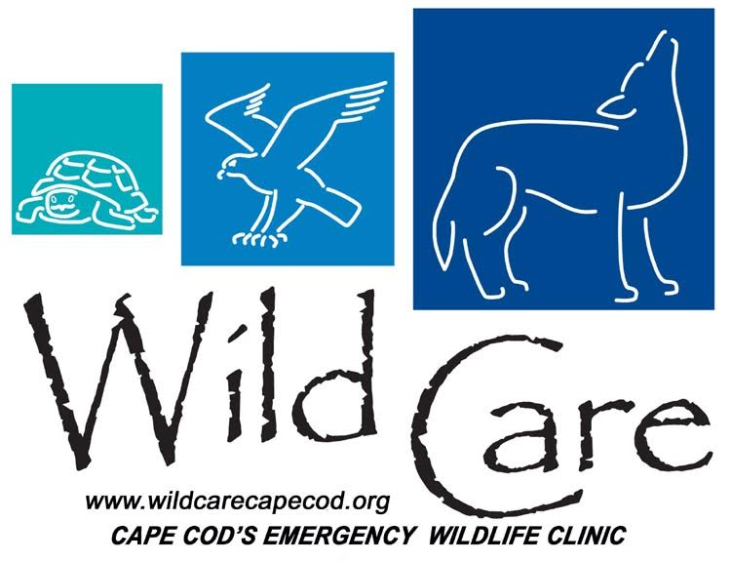

Wild Care, Inc.
Volunteer Release Form

Effective Date: _________/____________/2020

Volunteer Name: _____________________________________________________________________________

Address: ______________________________________________________________________________________

Primary Phone: ______________________________________________________________________________

Email: _________________________________________________________________________________________

Volunteer Organization: Wild Care, Inc.
Located: 10 Smith Ln.
Eastham, MA
Phone: 508-240-2255
Email: volunteer@wildcarecapecod.org

I, the above listed Volunteer, desire to work as a volunteer for Wild Care, Inc. and engage in the activities related to being a volunteer for a work project.

I hereby voluntarily, execute this Volunteer Waiver under the following terms:

I, the Volunteer, release and hold harmless, Wild Care, Inc. and its successors, and assigns from any and all liability, claims, and demands of whatever kind or nature, either in law or in equity, which arise or may hereafter arise from my volunteer work with Wild Care, Inc.

I understand that this Waiver discharges Wild Care, Inc. from any liability or claim that I, the Volunteer, may have against Wild Care, Inc. with respect to bodily injury, personal injury, illness, death, or property damage that may result from my participation on Wild Care, Inc.’s work site or off-work site. I also fully understand that Wild Care, Inc. does not assume any responsibility for or obligation to provide

Wild Care, Inc.
Volunteer Release Form

financial assistance or other assistance, including but not limited to medical, health or disability insurance, in the event of injury, illness, death or property damage.

I, the Volunteer, understand that I expressly waive any such claim for compensation or liability on the part of Wild Care, Inc. beyond what may be offered freely by the representative of Wild Care, Inc. in the event of such injury or medical expense.

I hereby release Wild Care, Inc. from any claim whatsoever which arises or may arise in the future on account of any first aid treatment or other medical services that are conducted in connection with an emergency during my time with Wild Care, Inc.

I understand that my time with any/all species, ill, injured, alive or dead may include various activities that may be hazardous to me and I herby expressly and specifically assume the risk of injury or harm in these activities and release Wild Care, Inc. from all liability for injury, illness, death, or property damage resulting form the activities of my time with Wild Care, Inc.

I grant unto Wild Care, Inc. all right, title, and interest in any and all photographic images and video or audio recordings that are made by Wild Care, Inc. during my work with Wild Care, Inc. including, but not limited to, any royalties, proceeds, or other benefits that are derived from such photographs or recordings.

I expressly agree that this Waiver is intended to be as broad and inclusive as permitted by the laws of the State of Massachusetts in the United States of America, and that this Waiver shall be governed by and interpreted in accordance with the laws of the State of Massachusetts. I agree that in the event that any clause or provision of this Waiver shall be held to be invalid by any court of competent jurisdiction, the invalidity of such clause or provision shall not otherwise affect the remaining provisions of this Release, which shall continue to be enforceable.

Volunteer’s Signature

Print Volunteer’s Name

_________________________________________________________________________________________________

